Installing pycryptodome

The installation is not difficult and is described here. <https://pycryptodome.readthedocs.io/en/latest/src/installation.html>

You can use pycryptodome on almost anything that runs Python, so you may choose your operating system (If you like “easy”, choose Ubuntu or Windows for this one.) Please use version 3 of Python. In Ubuntu run python3 to use Python version 3 and python to use Python version 2.

# Install Python3

## Ubuntu

Test whether Python version 3 is installed by typing (in a terminal)  
python3

If it is not installed use  
sudo apt install python3

Run Python 3 by typing python3. If you use python, you will get Python 2 or an error.

## Windows

Download the current Python version from <https://www.python.org/downloads/windows/> and install it. Note: several students installed more than one version of Python and got confusing results. It is easiest to have only one version.

When you install Python, it gives you the option to add Python 3.7 to your PATH environment variable. **DO IT!!** Otherwise, you wind up buried in weird directories when you use the command line.

In the custom installation make sure that pip is selected. IDLE is a klunky, but workable Integrated Development Environment (IDE). Maybe calling it an IDE is a little much. Anyway, it can come in handy.

Window has a limit of 260 characters in a file path. Since Python installs itself on a long file path already long (like C:\Users\SVGS\AppData\Local\Programs\Python\Python37\) the limit can cause problems.  
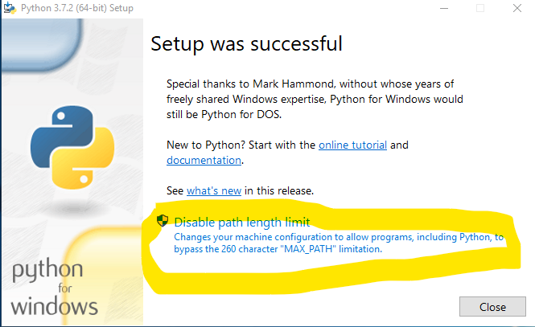

# Install PIP

PIP is the Python Package Installer. Once PIP is installed, adding Python modules that support PIP is easy.

## Ubuntu

In Ubuntu, execute  
sudo apt install python3-pip

Test the installation using  
pip3 --version

## Windows

PIP should already be installed in current versions of Python for Windows. If you are having problems running PIP, you may have forgotten to have Python added to your path when you installed Python.

### If you forgot to have Python added to your path

If that is so, open File Explorer and find your Python37 (or whatever version) directory. Right now, it is in C:\Users\your-user-name\AppData\Local\Programs\Python\Python37\. Also, the AppData directory is hidden, so you need to set View to show Hidden Items. While you are at it, check the box for File name extensions.  
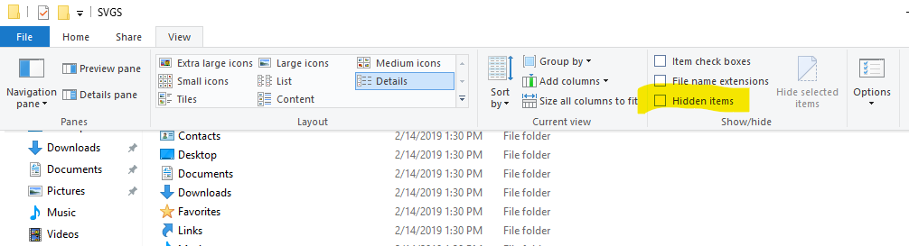

Copy the file path and add it to your PATH variable. Right-click properties of This PC in File Explorer select Advanced System Settings, and Environment Variables. Make sure that you have both the path to Python and the path to the Scripts directory under it. PIP needs the Scripts directory.  
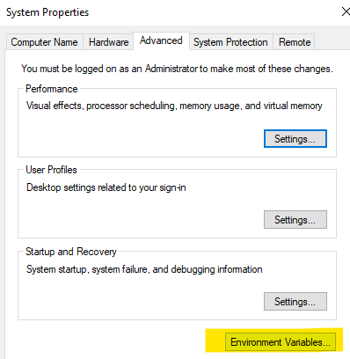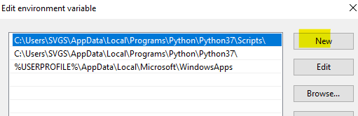

# Install pycryptodome

## Ubuntu

Use  
sudo pip3 install pycryptodome

Test the installation with  
python3 -m Crypto.SelfTest

If you do not get errors, your installation succeeded. The self-test is quite long, so you do not have to let it complete (use CNTL-C to force it to quit.)

## Windows

Use  
pip install pycryptodome

Test the installation with (case sensitive)  
python -m Crypto.SelfTest

If you don’t get errors, your installation succeeded. The self-test is quite long, so you don’t have to let it complete (use CNTL-C to force it to quit.)